FOUR Qs TO THE ‘QUILLIGAN SEMINARS’ MAY 7-18 2012
The Quality of the London based Quilligan SemInars reflected and Quickened a new dawning of the Quintessential truth that ALL LIFE IS GIFT.
Moreover the condensed experience emerging from so many starting points broke that enduring truth down into many constituent parts without loss of the vision of “prior unity”, that is inherent or “a priori” unity of existence.
This symbol reminds us of the bold formation of a prototype for a many-angled attempt at systemic change after facing the challenge of the New Economic Foundation’s eloquent and erudite ‘The Great Transition’ and the renewed awareness of complexity evolving from, for example, ’Synthesis.’

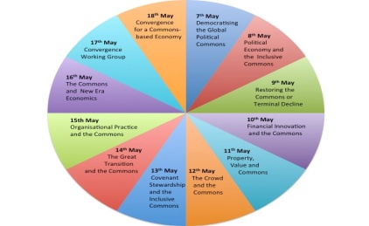
Using the metaphor of an elevator, the approaches and the engagements through the twelve days moved up and down through many levels of understanding reality, and ways of recognising those other levels with which any might be less familiar.
‘Commons’ provided the key in every instance for earthing the quintessential truth of Gift in the envisioning and movement from the present global ‘Economy of Degradation’ in all private and community capital towards an ‘Economy of Replenishment.’
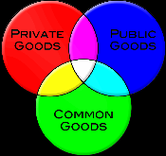
Continuity in this process of discernment and application is being shaped in a ‘Commons Knowledge Garden’ tended by the Commons Arising participants in viral mutuality and serviced by the London based ‘School of Commoning.’
In every participant’s mind a shift is proceeding as we draw towards recognition of a critical mass influential enough to peacefully and effectively disturb the dominant economy of degradation and pave the pilgrim path towards the economy of replenishment, in which we move from the human hubris focussed in ‘ownership’ to the intergenerational responsibility of ‘trusteeship.’
If any part of this brief account stirs you to questions or comments about following through,
please put them to
george@Community-Intelligence.com or
anna@schoolofcommoning.com or
peterchallen@gmail.com

Dear all -

Hywel, thanks so much for facilitating the meeting today. You brought energy, direction and simplicity to the process. You held a sense of confidence today which was essential. And I do think the event achieved the results we had hoped for.

George and Anna, I can't tell you how grateful I am for making the seminars possible. Your constant efforts supported everything. Your hard work and dedication made all the difference.

Mary Beth, you have been a distant, supporting presence in this process. You are one of my dearest advisers and friends, as you know. I am so blessed that you are in my life.

Helene, thank you for coming on board and taking on the important work of mapping the process. Your insights have already been very valuable in mapping our future. I look forward to working more closely with you.

Connor, thank you so much for your insights, your work on the webstie, and your great enthusiasm for the commons. Keep up the work in Waterloo.

David, what I saw of the datagraph was simply mind-expanding. I will work with you to fill in any gaps, just ask. What an incredibly powerful tool you are developing.

Yva, I'm so happy that you have taken an interest in helping us to think about outreach, networking and the ebook process. I am so impressed by the insight and compassion that you are bringing to this group. You are a breath of fresh air.

Peter, without your heart, your experience, your contacts, your faith, your energy, your brilliance, and your total commitment, none of this would have been possible. My gratitude for your efforts runs as deep as could be. You were the one who energized the field.

Esther, what insight you have contributed to the process of organizing the seminar that you sponsored and also the final one today. Getting to know you has been a joy for me. I must say that I have learned a great deal from your brilliance and compassion in developing results-oriented events.

All of you have taught me a lot. Please carry this work forward. It is deeply important. Please know that I will support you however I can.

with all my love

